This resource is an introduction to the advisor dashboard in Workday.

The advisor dashboard is the hub for advising activities and advisee information. Growing familiar with the advisor dashboard will help you complete your work quickly and easily.

INSTRUCTIONS – How to Access the Faculty Advising tab

- Log into Workday and click the Faculty Advising app from the homepage.
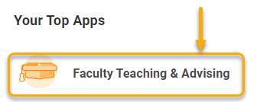

TIP: If you do not see this app, click the Menu in the top left-hand corner.
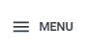
Click “Add Apps”
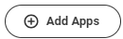
Type “faculty advising” in the search bar and click to add the app to your homepage.

- The Faculty Advising app will take you to the Advisee tab. All important tasks will originate here. See below for more information.

INSTRUCTIONS – How to Use the Advising Tab
From this tab you can view your advisees, access their record, review and remove holds, and locate contact information. You can also add student notes and look up the advisors for any other student.

Below is an overview of the Advising tab homepage.

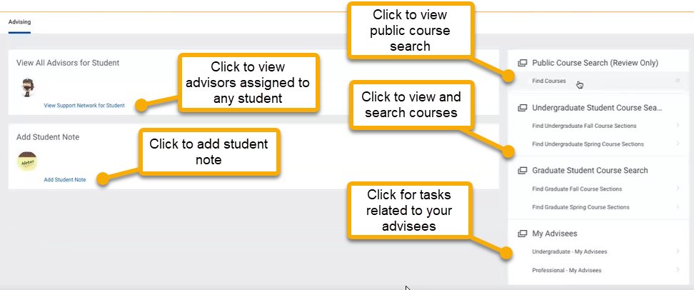

The View Support Network for Student displays advisors assigned to any student. If you want to look-up a student’s advisor, click View Support Network for Student and enter the student’s name or ID.

To add a student note, simply click Add Student Note and complete the required fields.

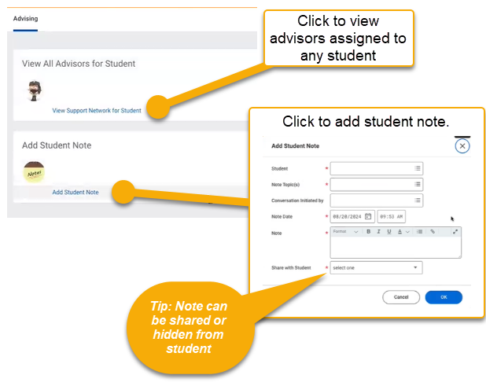
The Advising tab offers two course search options. The Public Course Search is the public facing course list. This may not be up to date. For the most accurate course search, use Find Undergraduate / Graduate Course Search.

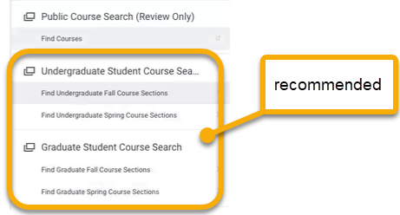

The “Undergraduate – My Advisees” link in the lower-right hand corner of the Advising tab displays the student records of your advisees.

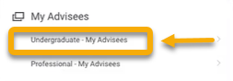

Many tasks can be accomplished here. For example, to remove advisor holds, click the student’s name to go directly to the student’s record. (See the Remove Advisor Holds guide for details.) Additionally, through the student record you can view the student’s Academic Progress Report, other active holds, and enrolled and waitlisted courses.

